Name______________________________________ Date:_________________
T: Experiment - Which materials are waterproof?
Object: | 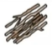  Sticks  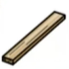  Or  wood | 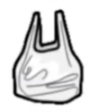  Plastic bag  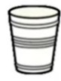  or Cup | 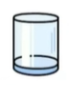  glass cup | 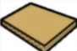  Cardboard  or  Paper | 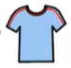  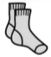  fabric
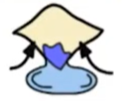
Absorbent
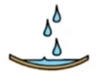
Waterproof
Which materials were waterproof? _________________________________
____________________________________________________________
Which material was the most absorbent? ___________________________

Which material was the least absorbent? ____________________________

